**1.Data Collection and Field work**

**1.1Purpose**

The system is an online application that can be accessed throughout the organization and outside customers as well with proper login provided, which will give better service to the customers.

**1.2 Scope**

The scope of the Mobile Service Provider and Operation Portal is as follows:

This system can be used as an application for the Mobile Service Providers of the Mobile Company to manage the product information. Customer logging should be able to upload the information of the any required mobile.

**1.3 Overview**

Overall description consists of background of the entire specific requirement. It also gives explanation about actor and function which is used. It gives explanation about architecture diagram and it also gives what we are assumed and dependencies. It also support specific requirement and also it support functional requirement, supplementary requirement other than actor which is used. It also gives index and appendices. It also gives explanation about any doubt and queries.

**1.4 Existing System**

The Existing system is a computerized system contains all the details of the mobile services providers are maintained in the individual databases. If customer wants the information they must keep a request to the admin authority and get the information. It’s a time delay process. And maintaining all the records in Excel sheets and paradox, clipper. If they want any record they have to search all the records. The whole process is now manually controlled. This requires maintaining the records of the queries coming from the corporate in the paper.

**Limitations in Existing System**

Maintaining the data in excel sheets and files is very hard to remember the file names in which the required data is feed. No easy access to the required queries. Data redundancy, inconsistency, lot of human work need to be done in order analyze the details present in the excel sheets. It leads to wastage of time.

**1.5Proposed System**

The Proposed system is a browser which is completely related to internet browsing. The web enabled information management system designed to automate the entire operations of a modern technology. Mobile Service Provider and Operational Portal allow multi-divisional, multi-department system handling that includes various Services.

Services:

News & Updates

Call Management Services

Astrology

Entertainment

Sports

Travel

**Advantages over Existing System**

1. This system provides a Common User Interface for the system to log on to the system.
2. Here the user interface is Graphical User Interface.
3. This application is a Web based Application.
4. Being a web based application it doesn’t require any client side installation.
5. Any number of users can interact with the system simultaneously.

**2.Data Analysis and Planning**

**2.1Feasibality Study**

Before approaching this project mobile service provider and operational portal we have done a feasibility study on various factors

**2.1.1Economic Feasibility**

Economic feasibility attempts 2 weigh the costs of developing and implementing a new system, against the benefits that would accrue from having the new system in place. This feasibility study gives the top management the economic justification for the new system.

A simple economic analysis which gives the actual comparison of costs and benefits are much more meaningful in this case. In addition, this proves to be a useful point of reference to compare actual costs as the project progresses. There could be various types of intangible benefits on account of automation. These could include increased customer satisfaction, improvement in product quality better decision making timeliness of information, expediting activities, improved accuracy of operations, better documentation and record keeping, faster retrieval of information, better employee morale.

**2.1.2Operational Feasibility**

Proposed project is beneficial only if it can be turned into information systems that will meet the organizations operating requirements. Simply stated, this test of feasibility asks if the system will work when it is developed and installed. Are there major barriers to Implementation? Here are questions that will help test the operational feasibility of a project:

Is there sufficient support for the project from management from users? If the current system is well liked and used to the extent that persons will not be able to see reasons for change, there may be resistance.

Are the current business methods acceptable to the user? If they are not, Users may welcome a change that will bring about a more operational and useful systems.

Have the user been involved in the planning and development of the project?

Early involvement reduces the chances of resistance to the system and in general and increases the likelihood of successful project.

Since the proposed system was to help reduce the hardships encountered. In the existing manual system, the new system was considered to be operational feasible.

**2.1.3Technical Feasibility**

Evaluating the technical feasibility is the trickiest part of a feasibility study. This is because, .at this point in time, not too many detailed design of the system, making it difficult to access issues like performance, costs on (on account of the kind of technology to be deployed) etc. A number of issues have to be considered while doing a technical analysis.

Understand the different technologies involved in the proposed system before commencing the project we have to be very clear about what are the technologies that are to be required for the development of the new system. Find out whether the organization currently possesses the required technologies. Is the required technology available with the organization?

**2.2 Software and hardware requirements**

**2.2.1Software Requirements**

Operating System : Windows XP/2003 or Linux/Solaris

User Interface : HTML, CSS

Client-side Scripting : JavaScript

Programming Language : Java

Web Applications : JDBC, JNDI, Servlets, JSP

IDE/Workbench : Eclipse with MyEclipse Plug-in

Database : Oracle/Access

Server Deployment : JBoss

**2.2.2Hardware Requirements**

Processor : Pentium IV

Hard Disk : 40GB

RAM : 256MB**3.Data design**

3.1System Design

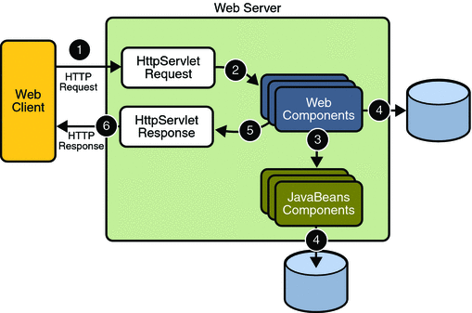

**Authentication**

**Functional Description**

* 1. Login to the system through the first page of the application*.*
  2. Change the password after login to the application.
  3. See his/her details and change it.
  4. Help from the system.

**Maintenance**

**Functional Description**

The Following Functional Components are supported by the system:

Functions Provided by the System:

* Products:
* Prepaid: The service that helps you give, words to every feeling, an expression to every emotion.
  + - Features
    - Handset Offers
    - Services
    - Tariffs Roaming
    - Know More
* Postpaid: It gives you the unlimited freedom to reach out to people in your special way.
* Monthly Plans
* Services
  + World Calling Cards
  + Home Calling Cards

3.2 Detailed Design

**UNIFIED MODELING LANGUAGE DIAGRAMS**

The unified modeling language allows the software engineer to express an analysis model using the modeling notation that is governed by a set of syntactic semantic and pragmatic rules.

A UML system is represented using five different views that describe the system from distinctly different perspective. Each view is defined by a set of diagram, which is as follows.

* + User Model View
    1. This view represents the system from the users perspective.
    2. The analysis representation describes a usage scenario from the end-users perspective.
  + Structural model view
    1. In this model the data and functionality are arrived from inside the system.
    2. This model view models the static structures.
* Behavioral Model View

It represents the dynamic of behavioral as parts of the system, depicting the interactions of collection between various structural elements described in the user model and structural model view.

* Implementation Model View

In this the structural and behavioral as parts of the system are represented as they are to be built.

* Environmental Model View

In this the structural and behavioral aspects of the environment in which the system is to be implemented are represented.

UML is specifically constructed through two different domains they are:

* UML Analysis modeling, this focuses on the user model and structural model views of the system.
* UML design modeling, which focuses on the behavioral modeling, implementation modeling and environmental model views.

Use case Diagrams represent the functionality of the system from a user’s point of view. Use cases are used during requirements elicitation and analysis to represent the functionality of the system. Use cases focus on the behavior of the system from external point of view.

Actors are external entities that interact with the system. Examples of actors include users like administrator, bank customer …etc., or another system like central database.

**3.2.1Class Diagram**

Class diagrams describe the structure of the system in terms of classes and objects. The servlet api class diagram will be as follows.

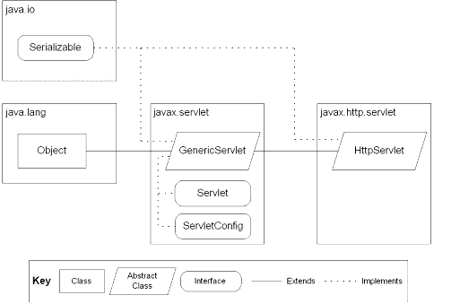

JSP: Implicit Objects

**3.2.2 Use-case Diagram**

**Admin**

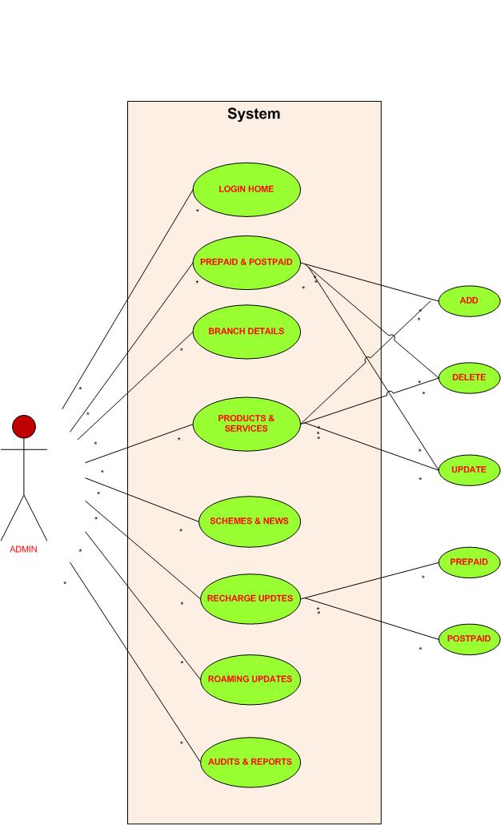

**Customer**

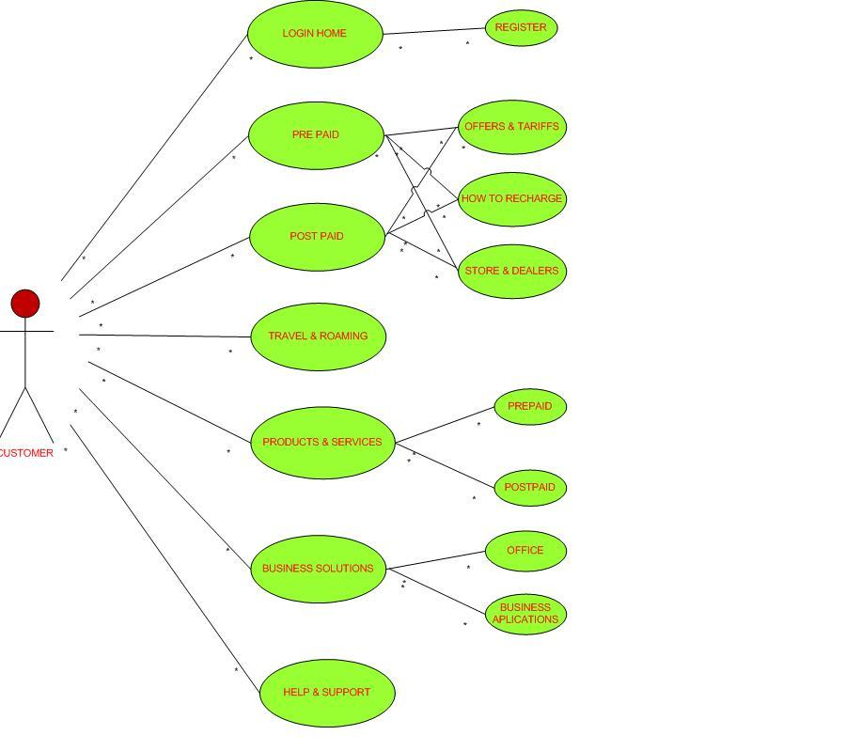

3.2.3**Component Diagram**

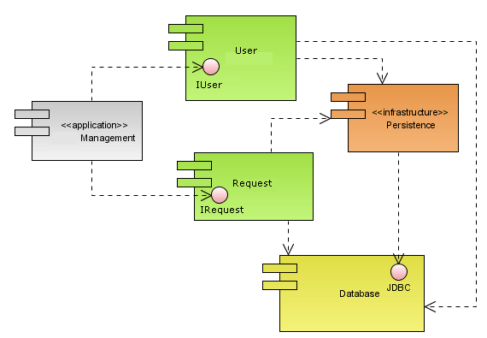

4.ER MODEL

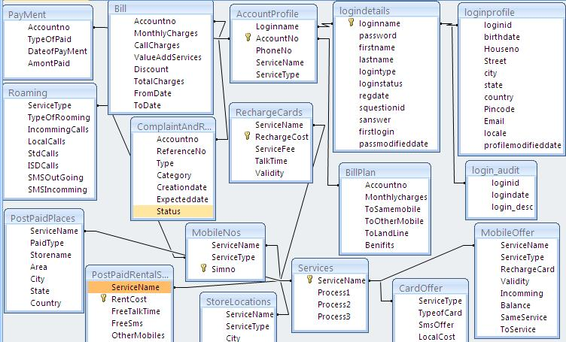

**5.DFD Model**

**5.1 DFD first level**

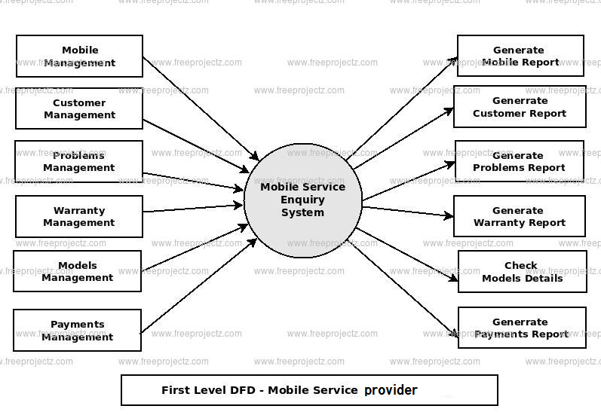

**5.2 DFD second level**

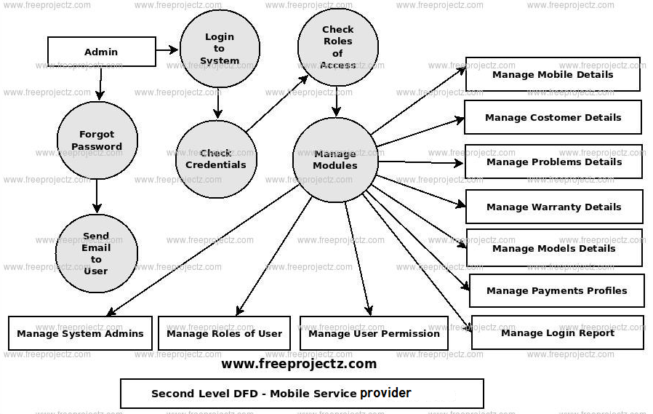

**6. Conclusion**

The **Mobile Service Provider Operations Portal** is a web-based application for primarily providing training to the employees who provide customized solutions to meet organizational needs.

The software is developed using Java as front end and Oracle as back end in Windows environment. The goals of this software are:

* Instant access.
* Improved productivity.
* Optimum utilization of resources.
* Efficient management of records.
* Simplification of the operations.
* Less processing time and getting required information.
* User friendly.
* Portable and flexible for further enhancement.

**7.Bibliography**

1.Software engineering ian sommerville

|  |  |
| --- | --- |
| 2.Core Java™ 2 Volume I – Fundamentals Edition | Cay S. Hortsman |
| 3 Pearson Education – Sun Microsystems | Gary Cornell |
|  |  |
| 4. Core Java™ 2 Volume II – Advanced  5. https://iansommerville.com/software-engineering-book/slides/ | Cay S. Hortsmn |
|  |  |
|  |  |
|  |  |
|  |  |
|  |  |
|  |  |
|  |  |
|  |  |
|  |  |
|  |  |
|  |  |
|  |  |
|  |  |
|  |  |
|  |  |
|  |  |